**Quest 9 – Filters and Dashboard**

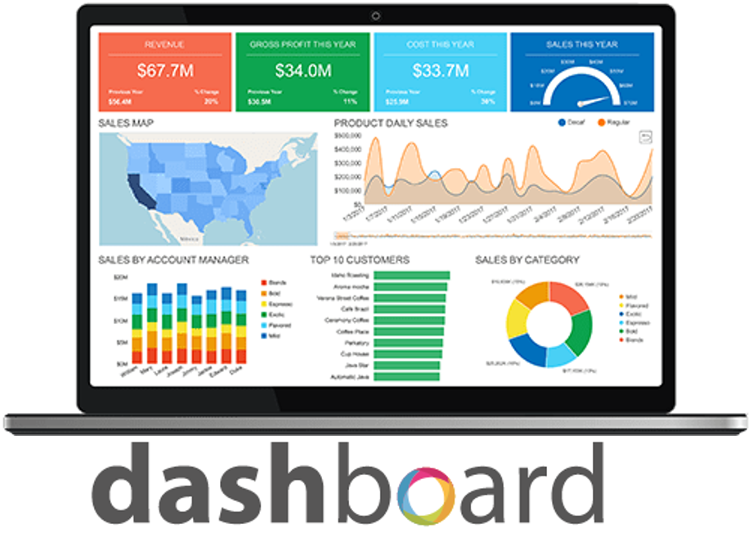

|  |  |
| --- | --- |
| Name: | Lucas Johnson |
| Instructions: | * According to several studies, the industry values documentation and excellent written and oral communication skills. The purpose of this part of the class is to encourage you to gain these skills. * Rename this document, fill-out this form, and submit it to the same link where you retrieved this material. * Backup your work; you may need this in the future or as part of an exam. * Organizations value attention to detail. As part of cultivating a culture of producing quality products and due diligence, please review your work at least twice before rendering them to your professor. Remember that resubmissions are not allowed. Thank you for your willingness to improve and to embrace an engineer's mindset. |

1. **Applying advanced filtering –** Let us take our filter skills up a notch! You want to find out what the five best performing stores are in terms of sales amount. To do this you will create a new bar chart that displays only those stores. After that, you will use some of your formatting skills learned in class to improve your visual.

Close any open reports, then download and open Applying_Advanced_Filtering.pbix from Canvas.

* Remove the "Budgeted Monthly Amount" chart to make room.
* Add a Clustered bar chart to the report, with the EntityName on the *axis* and the Amount as *values*.
* Go to the filter pane and add a *Top N* filter on EntityName.
* Show only the top five stores.
* Change the title of the visual to Top 5 Stores by Sales.
* Sort the columns in *ascending* order.

**What is the name of the 5th best performing Contoso store?**

|  |
| --- |
| Contoso Catalog Store |

Please reposition your visuals so that it would look like the dashboard below. Take a snapshot using Window's Snipping Tool. Make sure the encircled items are included. Place your image at the yellow box provided (after the example below).  Please do not forget to save your work. This is not the end of the quest, there are more to follow.

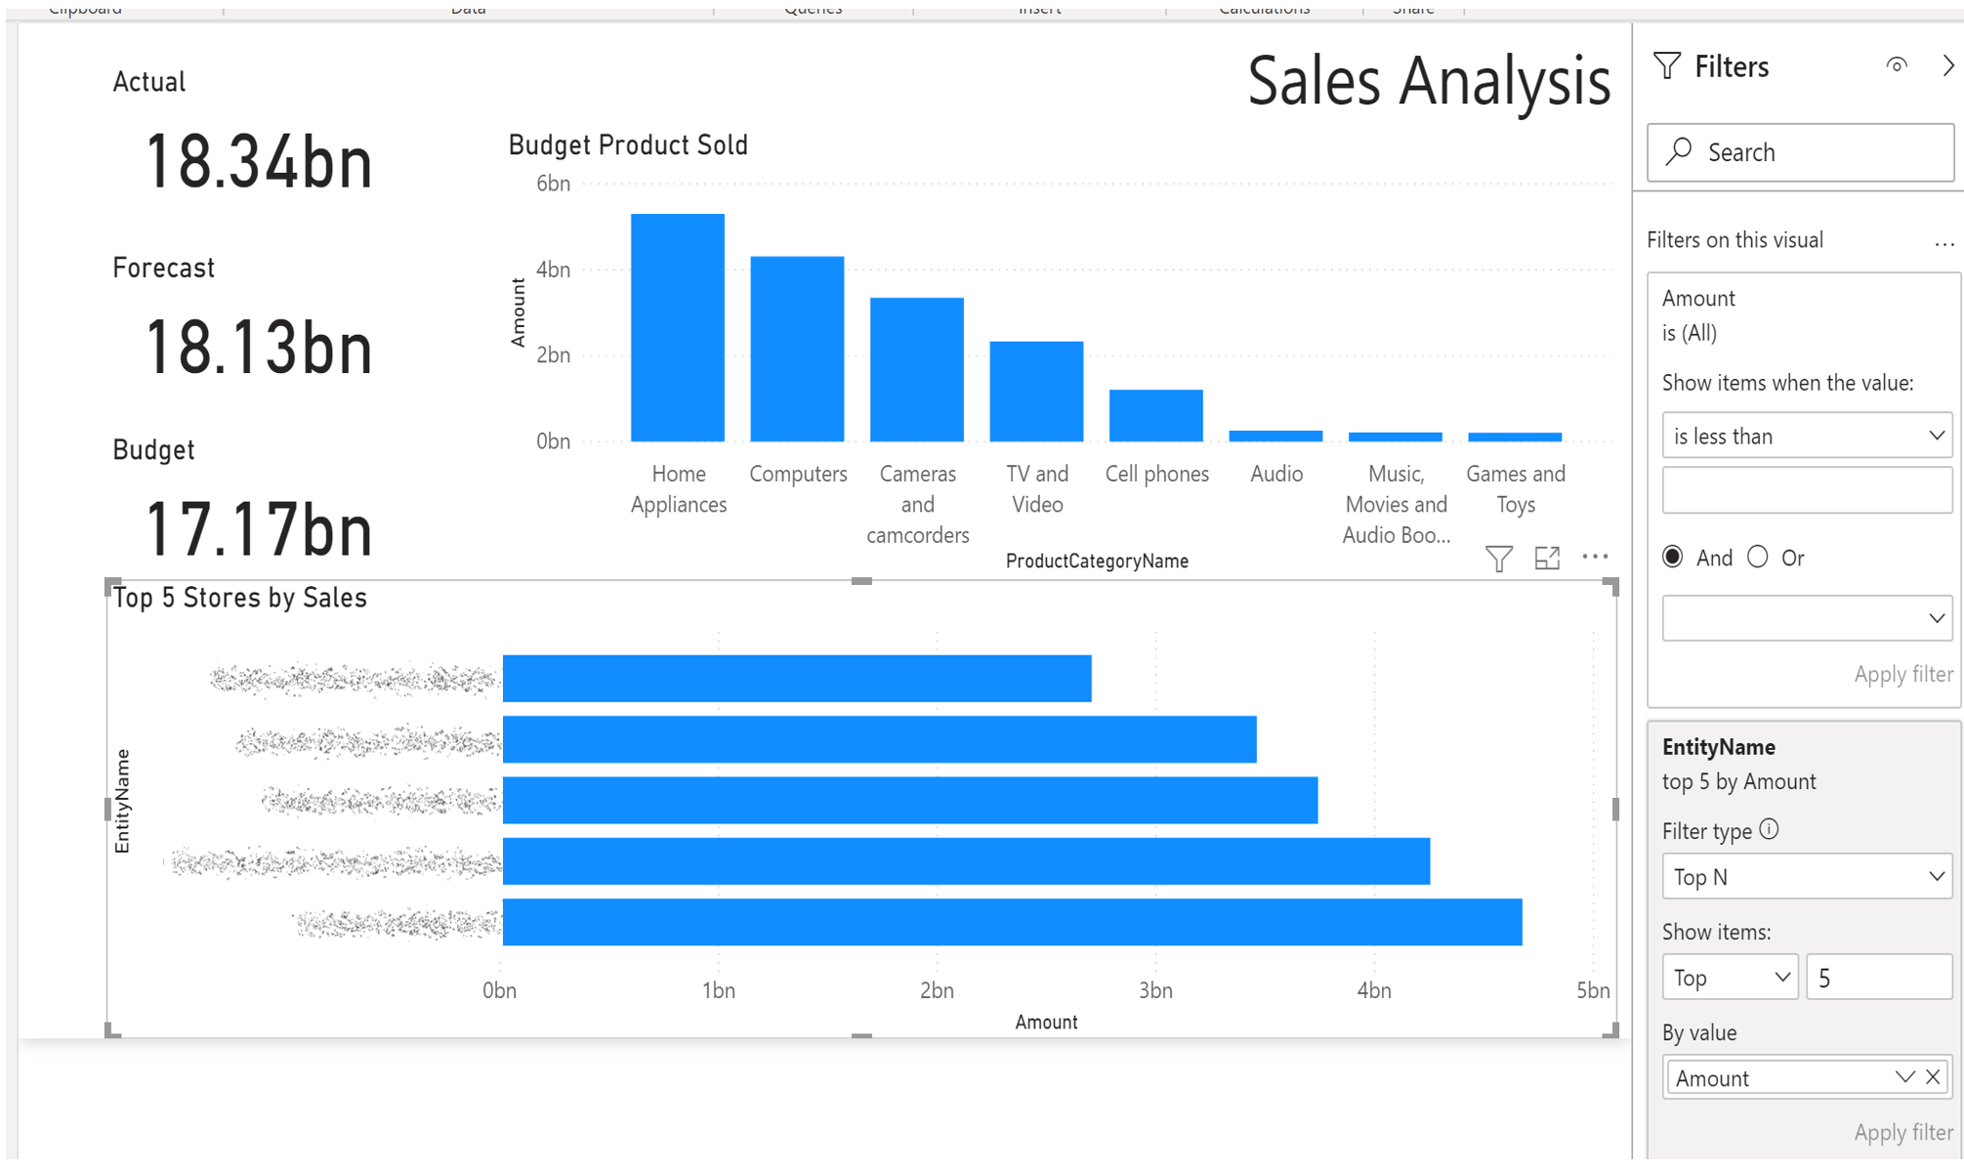



|  |
| --- |
| Please paste here your final dashboard. |

1. **Working with hierarchies –** You do not always want to look at all the available data in your Power BI visualizations. Depending on the business question you are trying to answer, you may want to drill down to look at additional relevant details. Drilling down accomplishes this by making uses of hierarchies. But how much do you know about hierarchies?

**Which statement about hierarchies is true?**

1. A hierarchy is a new column type.
2. A hierarchy enables the ability to show different levels of data without having to create new visuals.
3. A hierarchy is a specific drill-down visual you can use in Power BI.
4. A hierarchy is an add-on to the data view.

|  |
| --- |
| B |

|  |  |  |  |  |
| --- | --- | --- | --- | --- |
| Grading Criteria | 3  **Exceeds**  *Excellent*  Epic Wow | 2  **Meets**  *Satisfactory*  O.K. | 1  **Partially Meets**  *Below Expectations*  Not Yet | 0  **Does Not Meet**  *Unacceptable*  Fail |
| **Visualization –** How robust are the visuals? | Visualization is excellent :50% | Visualization is satisfactory :40% | Visualization is deficient :30% | Unfortunately, no visualization. |
| **Accuracy –** How accurate are the calculations? | Excellent computations :40% | Satisfactory computations :30% | Computations are deficient. :20% | Unfortunately, no computations. |
| **Time Management –** candidate used time wisely during development, presentation, and all aspects of the work submitted in a timely fashion. | Work submitted promptly :10% | Submitted within the allotted time :7% | Submitted late :3% | Unfortunately, too long, too short, or untimely. |